Mamp pro

1. What is MAMP PRO?

MAMP PRO is a configuration application that helps you set up and run the Apache web server and the MySQL database server. It also takes care of the configuration of different versions of PHP. It is the big brother of the free MAMP application. Both applications need the MAMP folder to run.

**Note:** MAMP PRO stores its databases in a different location than the MAMP application.

Translate:

1.什么是MAMP PRO？

MAMP PRO是一个配置的应用程序，可以帮助您设置和运行Apache Web服务器和MySQL数据库服务器。它也需要不同版本的PHP配置的照顾。它是免费的应用程序MAMP的大哥哥。这两个应用程序需要MAMP文件夹中运行。

**注意：**MAMP PRO存储它的数据库在不同的位置比MAMP应用。

## 2. Installation

### 2.1 Installation requirements

To use MAMP PRO, your system must meet the following requirements:

* A working MAMP installation (MAMP can be downloaded directly with the MAMP PRO installation package).
* Apple OS X, version 10.6.6 or later.
* A Mac with a 64-Bit-capable CPU.
* A user account that is part of the Admin Group. Go to Preferences > Users & Groups to confirm this.

### 2.2 Installing and upgrading MAMP PRO

* Download MAMP PRO from [https://www.mamp.info](https://www.mamp.info/).
* Double click on the MAMP_MAMP_PRO_3.0.pkg file in your Downloads folder.
* The System Installer will guide you through the installation process.
* If the installer detects an existing MAMP folder it will rename the current MAMP folder to MAMP_current_date.
* An existing "htdocs" folder will be moved to your new /Applications/MAMP folder.
* Confirm that all data has been transferred correctly before starting MAMP PRO.
* Your /Applications/MAMP_current_date folder can now be deleted. You may however keep it, so you can fall back to your original setup.

**Note:** You need administrator permissions to install MAMP PRO!

### 2.3 Uninstall

Use the MAMP PRO Uninstaller located in /Applications/MAMP PRO to remove MAMP PRO.

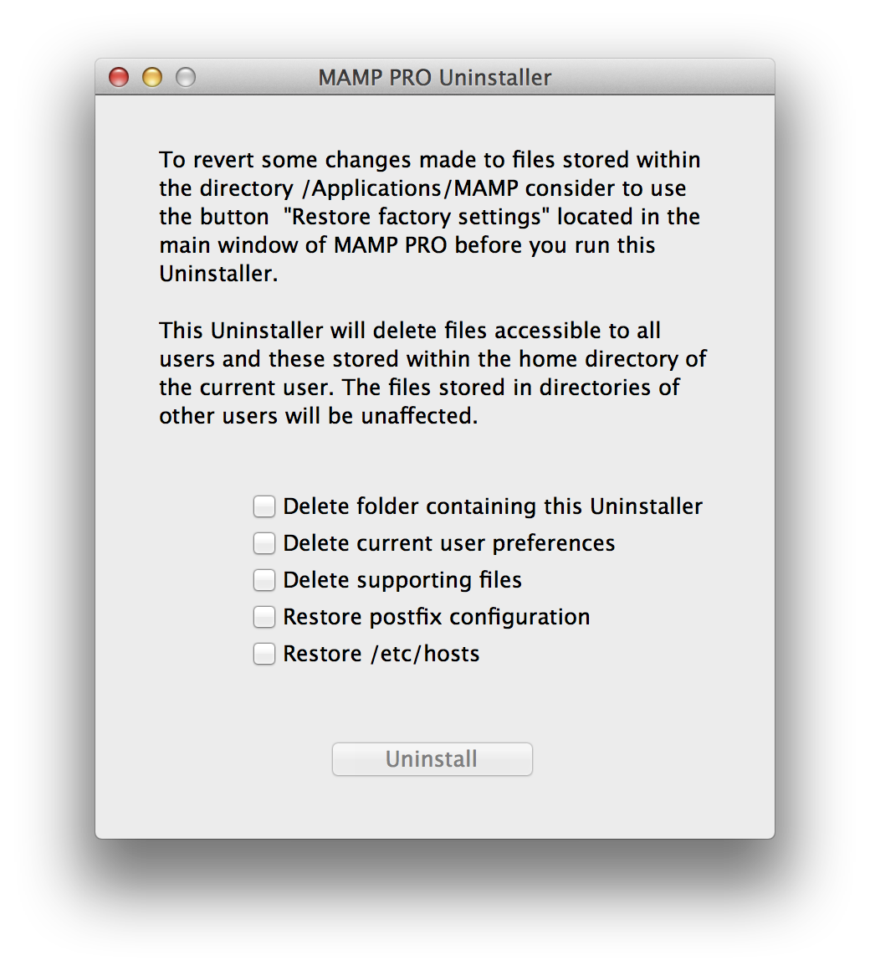

Drag the /Applications/MAMP folder to the Trash to complete uninstallation.

Translate:

2.安装

2.1安装要求

* 要使用MAMP PRO，您的系统必须满足以下要求：
* 一个工作MAMP安装（MAMP可以直接与MAMP PRO安装包下载）。
* 苹果OS X，10.6.6版本或更高版本。
* Mac计算机配64位功能的CPU。
* 这是管理员组的成员用户帐户。转至首选项>用户和组证实了这一点。

2.2安装和升级MAMP PRO

* 从https://www.mamp.​​info下载MAMP PRO。
* 双击你下载文件夹中的文件MAMP_MAMP_PRO_3.0.pkg。
* 该系统安装程序将引导您完成安装过程。
* 如果安装程序检测到现有MAMP文件夹将重命名当前MAMP文件夹MAMP_current_date。
* 现有的“htdocs目录”的文件夹将被移动到新的/应用程序/ MAMP文件夹。
* 确认所有的数据已开始MAMP PRO之前正确传输。
* 你/应用程序/文件夹MAMP_current_date现在可以删除。不过，你可以留着吧，这样你就可以回落到原始设置。

**注意：**您需要管理员权限才能安装MAMP PRO！

2.3卸载



使用位于/ Applications/ MAMP PRO的MAMP PRO卸载程序来删除MAMP PRO。

为/ Applications/ MAMP文件夹拖到废纸篓完成卸载。

3. First Steps

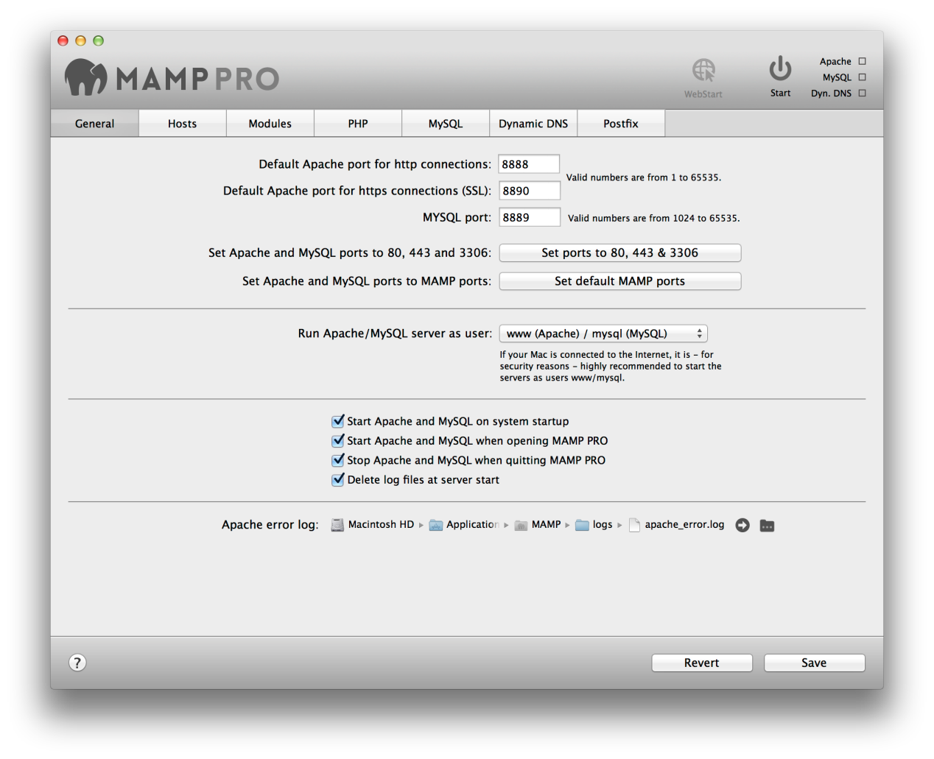

When the MAMP PRO application is launched for the first time its helper tools will be installed. You will be prompted to enter your admin password.

Click on the Start button in the title bar to launch Apache and MySQL. In the status display, the launch status of the server is displayed. The web server uses port 8888 by default. This port must be specified when calling the local web page in the browser, e.g.: [http://localhost:8888](http://localhost:8888/)!

Your default host for MAMP PRO is localhost. The files for localhost are initially located in the/Applications/MAMP/htdocs folder. See the Hosts section for more information on what a host is and how to create additional hosts.

### 3.1 Main GUI Elements

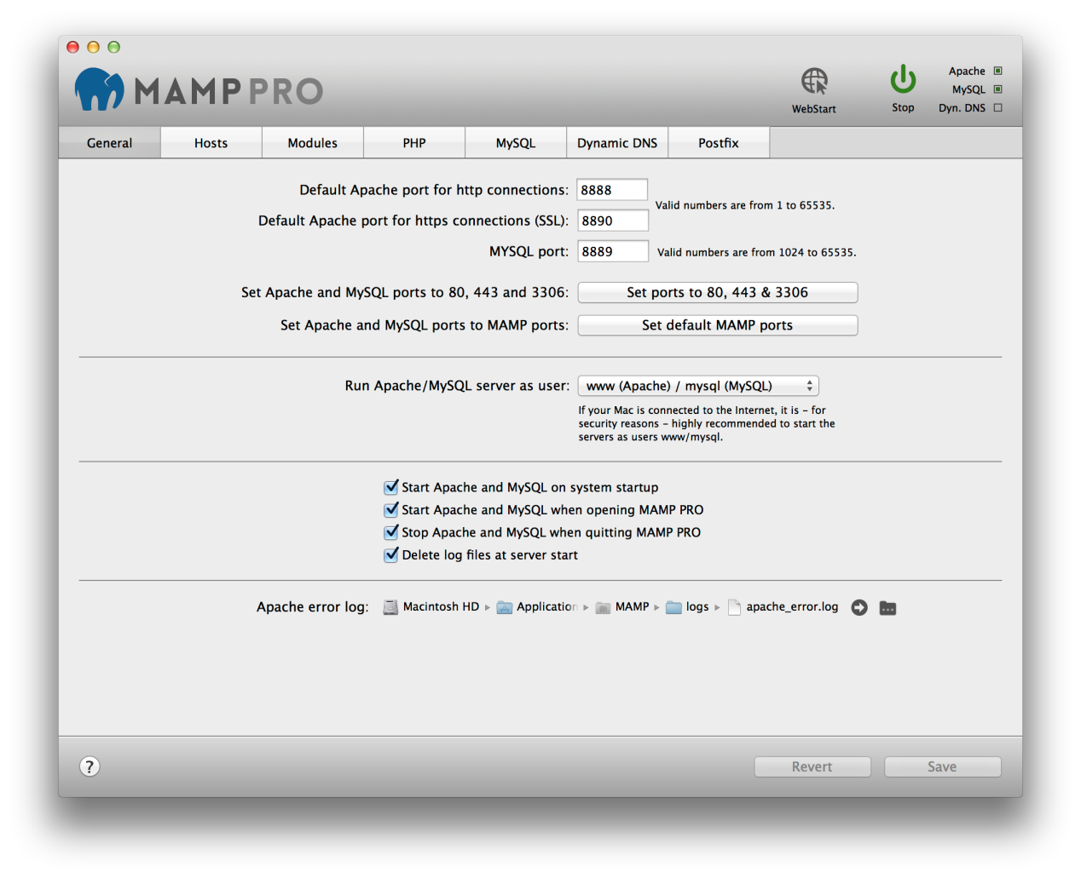

|  |
| --- |
| WebStart Open the MAMP PRO start page of your local web server. Additional information about the MAMP PRO start page is in the ‘Hosts’ section. |
| Start/Stop Starts or stops the Apache and MySQL services of the MAMP PRO server. |
| Status The status display in the upper right corner shows the started services (Apache, MySQL and Dyn. DNS). |
| Revert Discards all changes, which have not already been confirmed with ‘Save’. |
| Save Save your changed settings. |

### 3.2 Meaning of Icons

 Change a file location, including the location of the document root, or a log file.

 Prepare an e-mail with the Xip.io URL of a host.

 Modify the access rights of a document root folder.

 Open a disk location in the Finder, or a host in the web browser.

 Provide more information, including phpInfo().

 Indicates that information is missing.

Translate:



3.第一步

当MAMP PRO应用程序启动首次的辅助工具将被安装。系统将提示您输入管理员密码。

在标题栏中点击开始按钮，启动Apache和MySQL。在状态显示，则显示服务器的启动状态。 Web服务器的默认端口8888。在浏览器中调用本地的网页时，必须指定此端口，例如：HTTP：//本地主机：8888！

对于MAMP PRO的默认主机是localhost。 localhost的文件最初位于/应用程序/ MAMP/ htdocs文件夹。见主机部分的主机是什么的详细信息，以及如何创建其他主机。

3.1主要GUI元素



**在webstart**

打开你的本地Web服务器的MAMP PRO起始页。关于MAMP PRO开始页的更多信息，在“主机”部分。

**启动/停止**

启动或停止MAMP PRO服务器的Apache和MySQL服务。

**状态**

在右上角的状态显示已启动的服务（Apache，MySQL和和的Dyn。DNS）。

**还原**

放弃所有的变化，这尚未得到证实“保存”。

**保存**

保存更改的设置。

3.2含义的图标

  更改文件位置，包括文档根目录的位置，或日志文件。

  准备一个电子邮件与主机的Xip.io URL。

  修改文档根目录文件夹的访问权限。.

  打开Finder中的磁盘位置，或在Web浏览器的主机。

  提供更多的信息，包括phpinfo（）函数。

  指示信息被丢失。

4. Host and Server Settings

|  |
| --- |
| Ports Server programs, when addressed via the network, need to be assigned to a certain network port. This way, multiple server programs may run on one server machine. Every service has a default port: The Apache web server typically uses port 80, the MySQL database server utilises port 3306.  These ports are configurable. The default configuration for MAMP PRO uses ports 8888, 8889 and 8890. That way, the MAMP servers can run alongside other servers installed on your Mac. Should ports 8888, 8889 or 8890be in use by a different application, please change the values accordingly.  The button Set ports to 80, 443 & 3306 will set the ports to the value commonly used on the internet. The buttonSet default MAMP ports will reset the ports for Apache and MySQL to 8888, 8889 and 8890. |
| Start Apache / MySQL as user Production servers typically use www/msql to run Apache and MySQL. These users may not have the right to access your files, therefore it’s generally a good idea to run them under your own username.  **Note:** You should only start the servers with your own user name when the machine is adequately protected against malicious attacks from the internet. Malicious scripts on your server may enable unlimited access to your personal data. |
| Start Apache and MySQL at system start Apache and MySQL are started during startup of the OS, this means that the services are available before a user has logged into the system. |
| Start Apache and MySQL at startup of MAMP PRO The services will start automatically at startup of MAMP PRO. |
| Stop Apache and MySQL at shutdown of MAMP PRO The services will be stopped automatically when MAMP PRO shuts down. |
| Delete log files at server startup The log files will be emptied before startup of the services. That way only current entries will be in the log files. |
| Apache Error Log If any errors occur at startup or during execution of the Apache server, the messages will be saved in a log file. |

### 4.2 Hosts

#### 4.2.1 General Settings (Host)

MAMP PRO uses virtual hosts to allow Apache to serve different websites. The virtual host [localhost] is created by default and cannot be deleted. You can add an unlimited number of hosts allowing you to create one host per project. Every host can have it’s own directory to store html, php files, and images. This directory is called Document Root.

The name of a host [server name] must be unique, often it’s practical to use a reverse domain naming scheme to easily identify them (e.g. use de.appsolute.mamp instead of mamp.appsolute.de). The unreversed name may conflict with an outside domain name.

To create a new host press the ‘Plus’ button at the bottom left of the screen. Replace the default host name. The second required field to complete the setup of a new host is a location for its files [document root].

Click on the folder icon to choose a document root. Use the Right Arrow button to open the folder in the Finder.

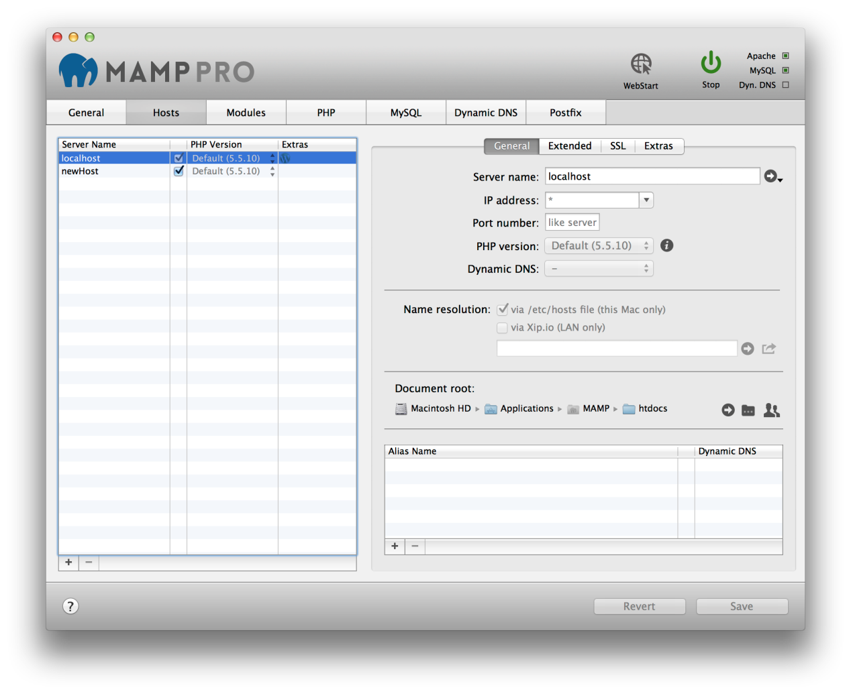

The document root is also known as the web root folder. MAMP PRO will automatically add an index.php file and a MAMP image to this location when Apache is restarted and the folder is empty.

**Server name**

The Server Name and Port number in combination must be unique within MAMP PRO. The host name may only contain letters and/or numbers, as well as dashes ("-"); but it may not begin or end with a "-" character. Names are not case-sensitive (upper and lower-case letters are not distinguished.)



If the servers are running you can use the Right Arrow button to open a host in your web browser.

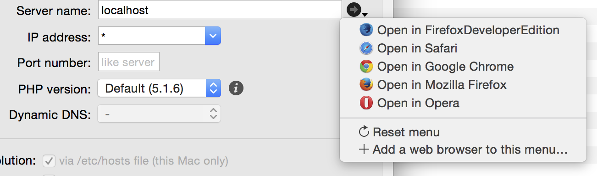  
**IP Address**

If this field is left empty or contains an ‘*’ Apache will use one of the computer’s IP addresses to access this host. If you want to choose which of the IP addresses should be associated with a host, then select it from the pop up menu.

**Port Number**

Determine the port with which the virtual host is accessible. Valid values are from 1 to 65535. In most cases the preset value does not need to be changed.

**PHP version**

Determine which version of PHP a host will use. This can only be set when Individual PHP version for every host (CGI)is set in the PHP section of MAMP PRO.

If you select the Standard PHP version MAMP PRO will automatically adapt this setting if you choose a new standard version in the PHP tab. Use a fixed setting to tell MAMP PRO not to alter the PHP version.

Sounds complicated? Let’s take a look at an example: The default version is set to 5.5.9. You have oneHost set to PHP version “Default (5.5.9)”, anotherHost set to “5.5.9” and yetAnotherHost set to “5.3.28”. If you set the PHP version in the PHP section to 5.4.25, MAMP PRO will adapt the PHP version of oneHost to this version (it is set to always use the standard version). The other 2 hosts will not be changed.

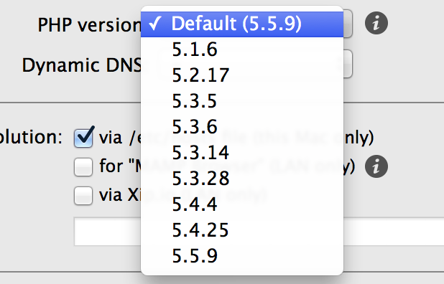

The  button will open up a webpage with information about the PHP version used, including all its extensions.

**Dynamic DNS**

Determines, if this virtual host is accessible with the Dynamic DNS service from the internet.

**Name resolution**

This will determine how your system will map host names to ip addresses.

**via/etc host file (this Mac only)**

The basic mapping mechanism which uses the the file /etc/hosts.

**via Xip.io (LAN only)**

Allow other computers on your local network to access your web site. Using the Share button you can send the Xip.io address to other users.

**Note:** The Xip.io addresses will only work in your local network. They are temporary and may become invalid if you restart your Mac. Also make sure that your Internet router is not blocking Xip.io calls by using a DNS Rebind protection. If the router does this you can either deactivate this function, add Xip.io as an exception or not use the router as DNS server in your Macs network setting

**Document root**

The location of the documents (HTML/PHP files etc.) of a virtual host is called a document root.

**Alias Name**

Aliases are additional names for your virtual host. The same constraints apply to these additional names as to the host itself. Add aliases with the plus-button.

**Access Rights for Document Root Directory**

For Apache to be able to access the files inside the document root folder and serve them to a web browser it needs adequate rights. If you use the user www to start Apache, then this user must have the right to access the files inside the document root folder. Typically this is not the case. You can either adapt the access rights or use the current Mac user to start Apache.

During the development phase of a site it is easier to use the current Mac user to start Apache. The user www is generally only used on production servers.

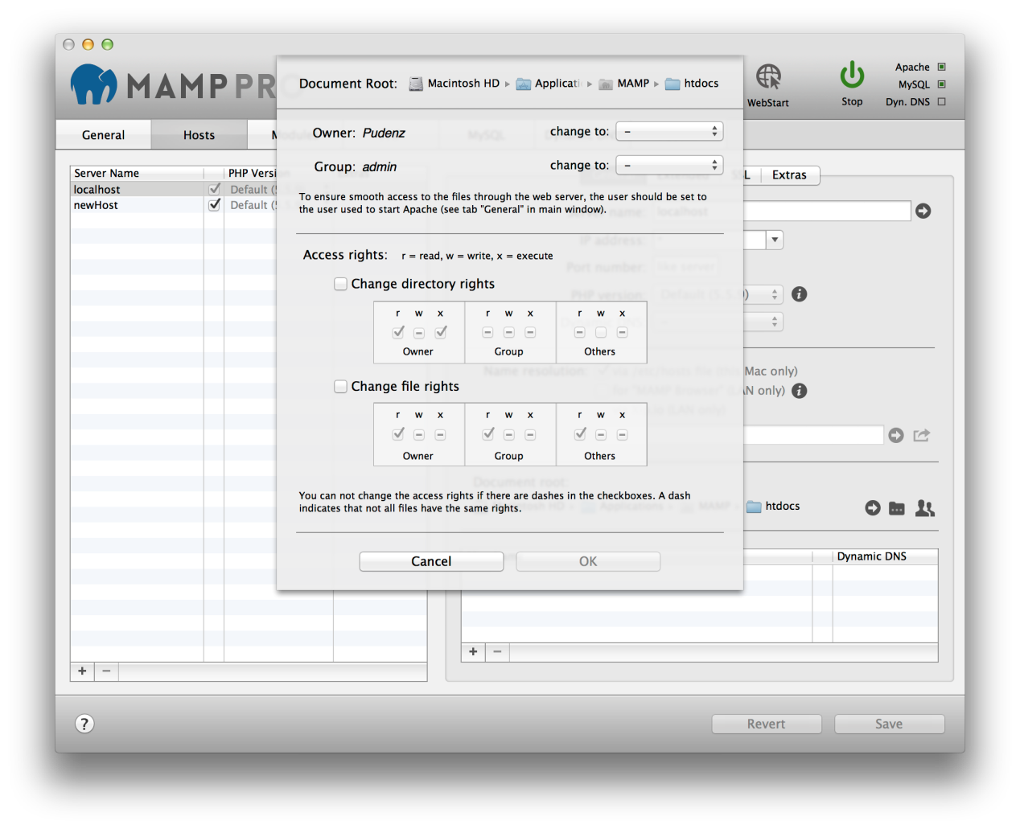

If Apache is reporting “access denied” in its error log or parts of your web pages are missing this might be due to access rights problems.

The rights dialog of MAMP PRO looks complicated at first sight but is actually very powerful. Not only does it show you the access rights of the document root folder but also all the rights of all the subdirectories and files inside it. A “-“ indicates that not all objects have the same rights.

**Owner**

The user who owns the directory and all the subdirectories and files in it.

**Group**

The group who has access to the directory and all the subdirectories and files in it.

**Access Rights**

You can change directory and files access rights separately.

#### 4.2.2 Extended (Host)

Extended options can be set for the selected virtual host in the table. These options are security relevant!

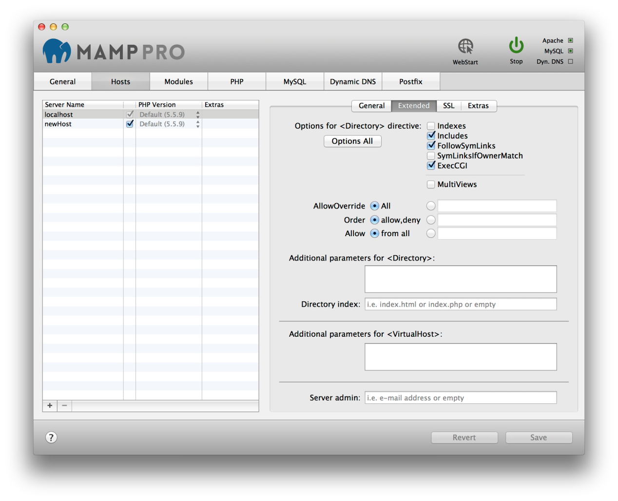

**Options for <Directory> directive**

**Indexes**

Activates or deactivates "directory browsing". If there is no index.html, index.php, etc in the document root, the content of the folder is displayed when this option is enabled. Without this option, nothing will be displayed or an error message will appear.

**Includes**

Allows the use of Server Side Includes (SSI).

**FollowSymLinks**

Allows the use of symbolic links as reference to documents in other directories. This is an elegant feature if you would like to reference to objects, that are outside of the directory tree (e.g. protocol files of the web server), but know you want to avoid the hiding of objects through the URL tree.

**SymLinksIfOwnerMatch**

Restricted version of "FollowSymLinks". Allows reference to objects via symbolic links only if the owner matches.

**Exec-CGI**

Permit CGI execution.

**Multiviews**

Allows the use or disabling of dynamic documents depending on the language.

**Directory Index**

Determine which file Apache should serve if no filename is given in a address. By default it is either index.html or index.php.

**Server admin**

The e-mail address Apache will send error messages to.

**Additional parameters for <Directory>**

**Additional Parameters for <VirtualHost>**

These directives go directly to the httpd.conf file.

**Note:** Watch out for typos, they will otherwise prevent Apache from starting up.

#### 4.2.3 SSL (Host)

To encrypt traffic from Apache to a web browser you can use SSL.

Use “Create self-signed certificate” if you want to test SSL functionality.

If you want to secure a productive server you should get the Certificate file and the Certificate key file from a Certified Authority (CA).

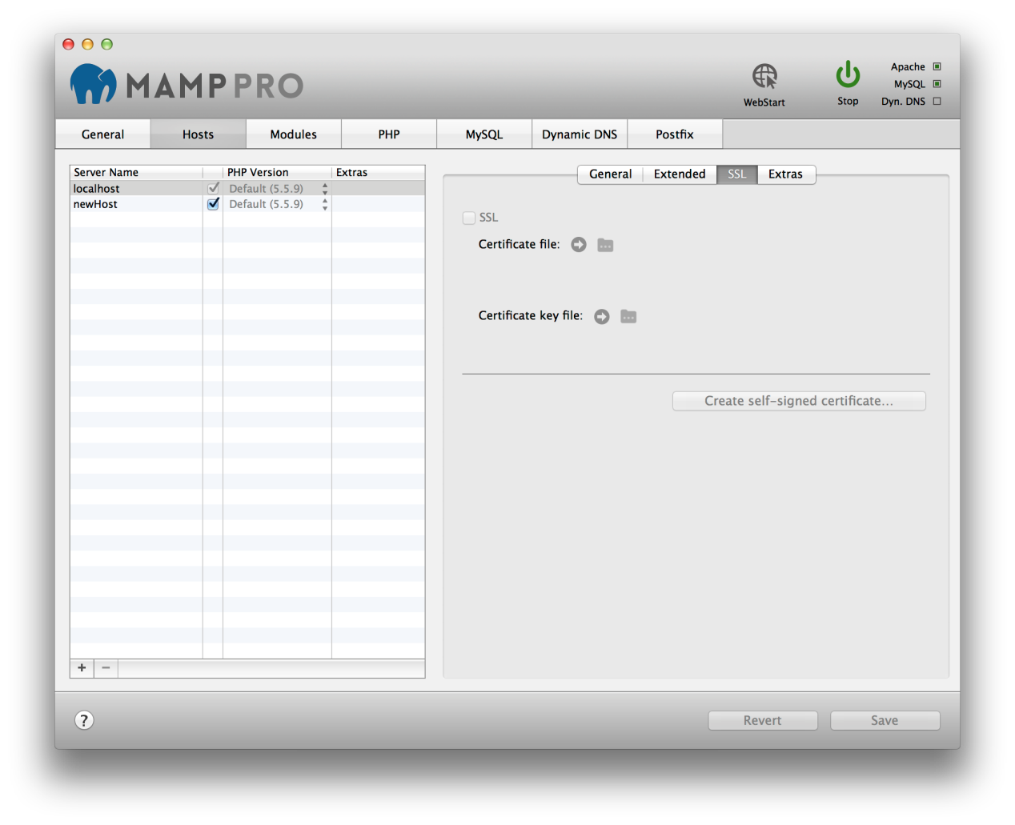

#### 4.2.4 Extras (Host)

MAMP PRO allows you to easily add popular packages to your hosts which we call Extras. Extras will always be loaded from the appsolute servers if you have an Internet connection. Over time more Extras will become available.

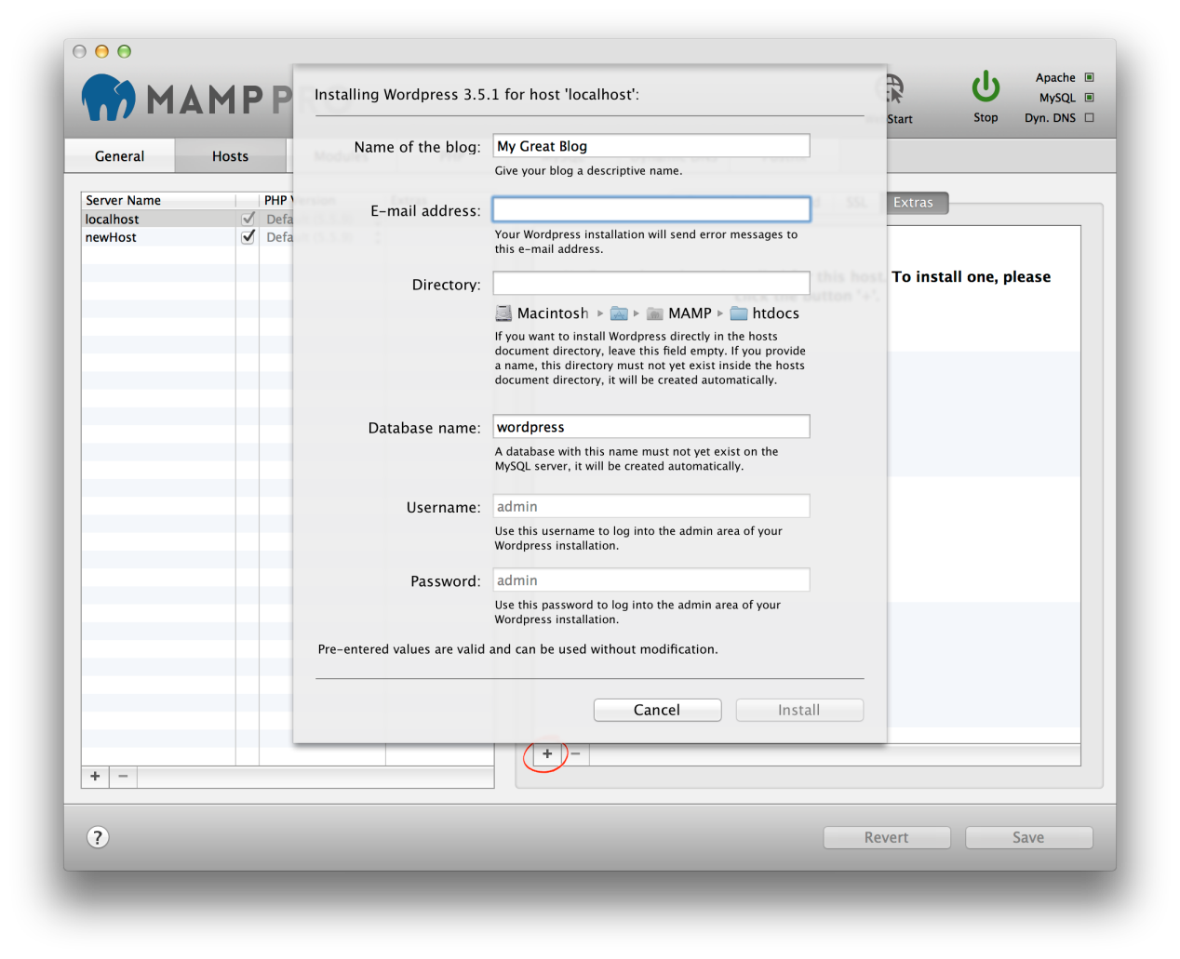

**Note:** The availability of an Extra will be affected by your hosts PHP version, Internet connection, cached Extras and available disk space.To add an Extra, press the plus button on the lower left side of the ‘Extras’ panel. The plus button has a red circle around it if you have no Extras installed.

##### 4.2.4.1 Wordpress

Name of the blog:

Name your blog.

Email address:

Your email address.

Note: You must enter a valid email address to setup a Wordpress installation.

Directory:

The installation directory. If it is left blank the Wordpress files will be copied directly to the document root folder.

Note: Do not install over a previous installation of Wordpress! Files will be overwritten without warning

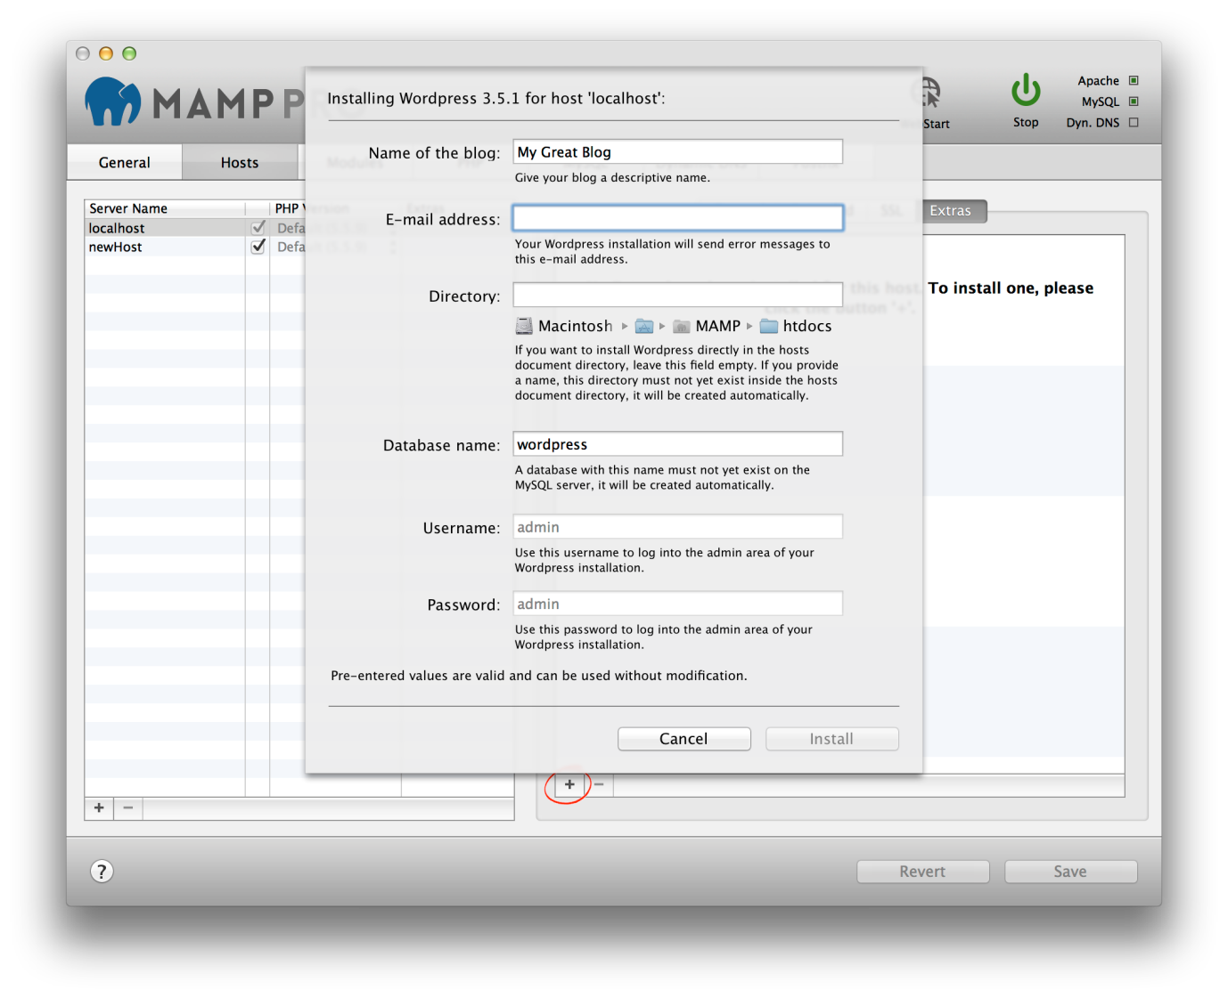

Database name:

Set the name of your database schema which will be added to your local database. After installation you can view this database for this instance of Wordpress using phpMyAdmin, Sequel Pro, or MySQLWorkbench.

Username:

The Wordpress admin.

Note: You will need this username to login into your new of Wordpress blog, please write this down.

Password:

The Wordpress admins default password.

Note: You will need this password to login into your new Wordpress blog, please write this down.

##### 4.2.4.2 Joomla

Joomla installations can share a single MySQL database if you provide a unique table prefix during installation. To use an existing database enter the name of the database and a unique table prefix. To create a new database use a unique database name, table prefix must not be empty.

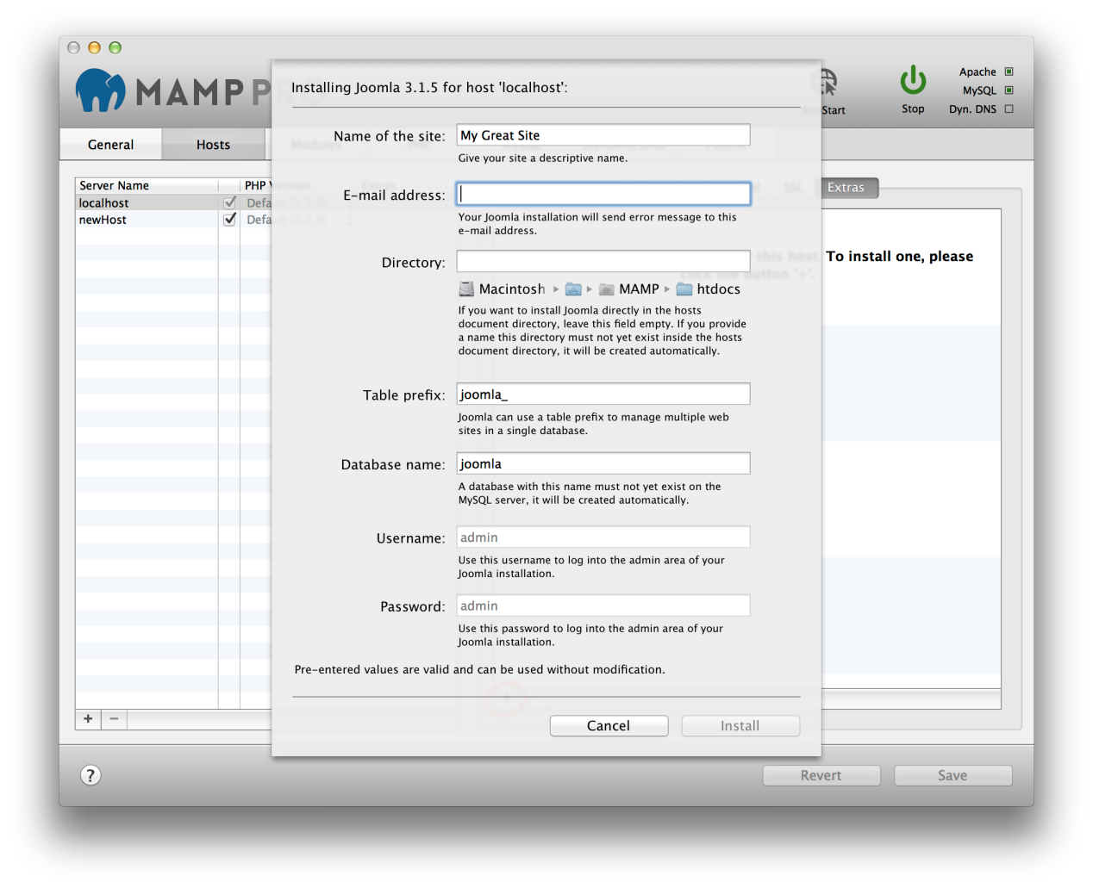

Table prefix:

Set the name of your database schema prefix. Joomla offers the ability to manage multiple websites using a single database schema.

Database name:

Set the name of your database schema which will be added to your local database. After installation you can view this database for this instance of Joomla using phpMyAdmin, Sequel Pro, or MySQLWorkbench.

##### 4.2.4.3 webEdition

webEdition will always be installed in a folder called webedition inside the document root folder.

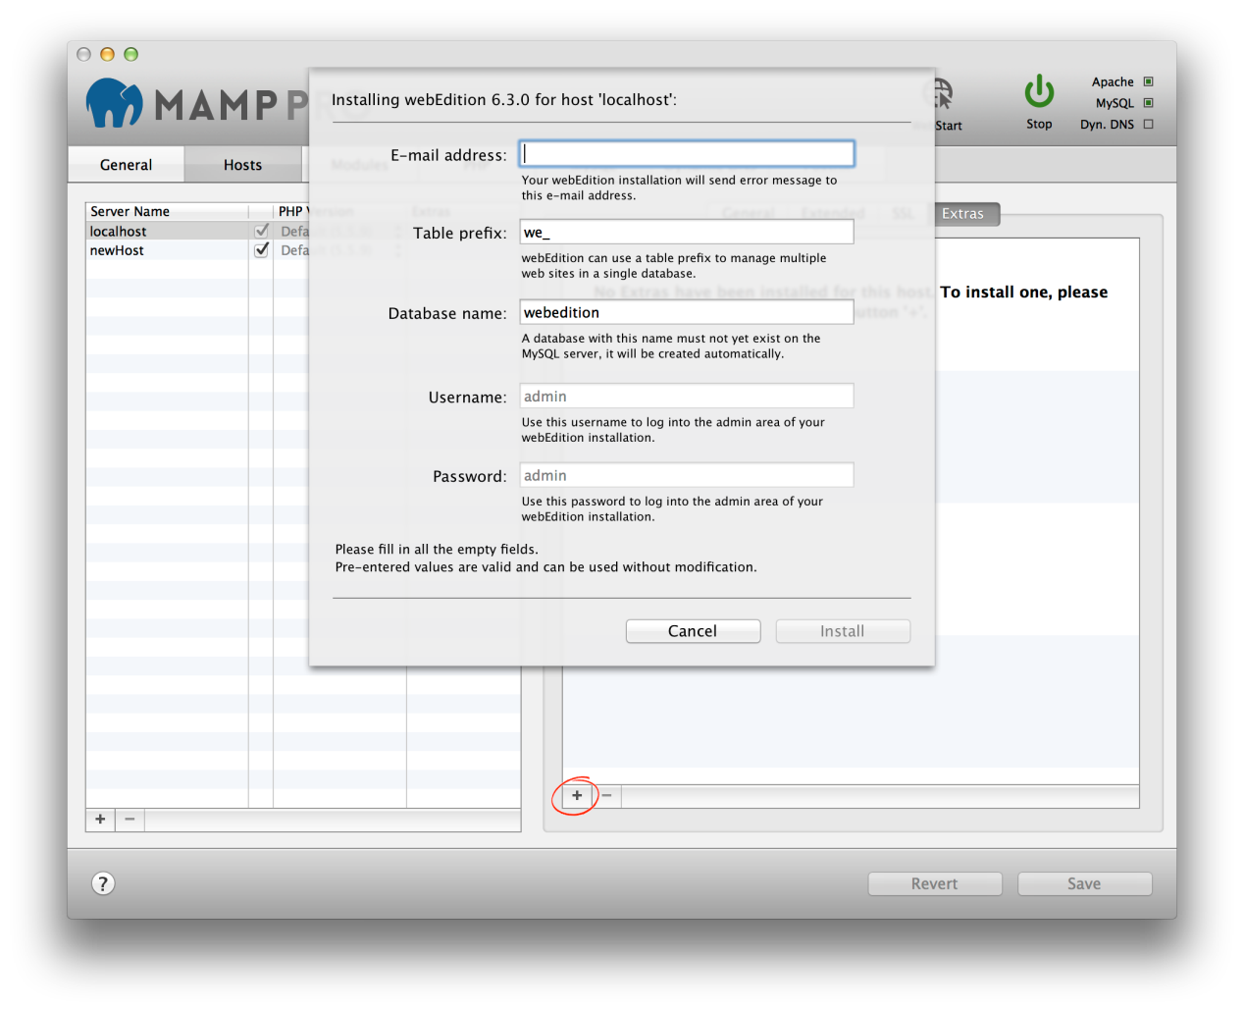

able prefix:

Set the name of your database schema prefix. webEdition offers the ability to manage multiple websites using a single database schema.

Database name:

Set the name of your database schema which will be added to your local database. After installation you can view this database for this instance of webEdition using phpMyAdmin, Sequel Pro, or MySQLWorkbench.

Note: When a Content Management System is setup the host name and Apache port number is stored in its database. Going forward the Apache port in MAMP PRO cannot be changed. A change in the Apache port will result in breaking the CMS, returning only a vague error message. Content Management Systems usually provide a mechanism for changing the host and port names. If changes are made in the CMS, then they must also be made in MAMP PRO.

### 4.3 Modules (Apache)

The Apache Web Server installed by MAMP PRO comes with many modules pre-installed.

**Apache Modules**

The web server modules can be activated or deactivated depending on your needs. Module Description provides information pertaining to features and functions of the selected module.

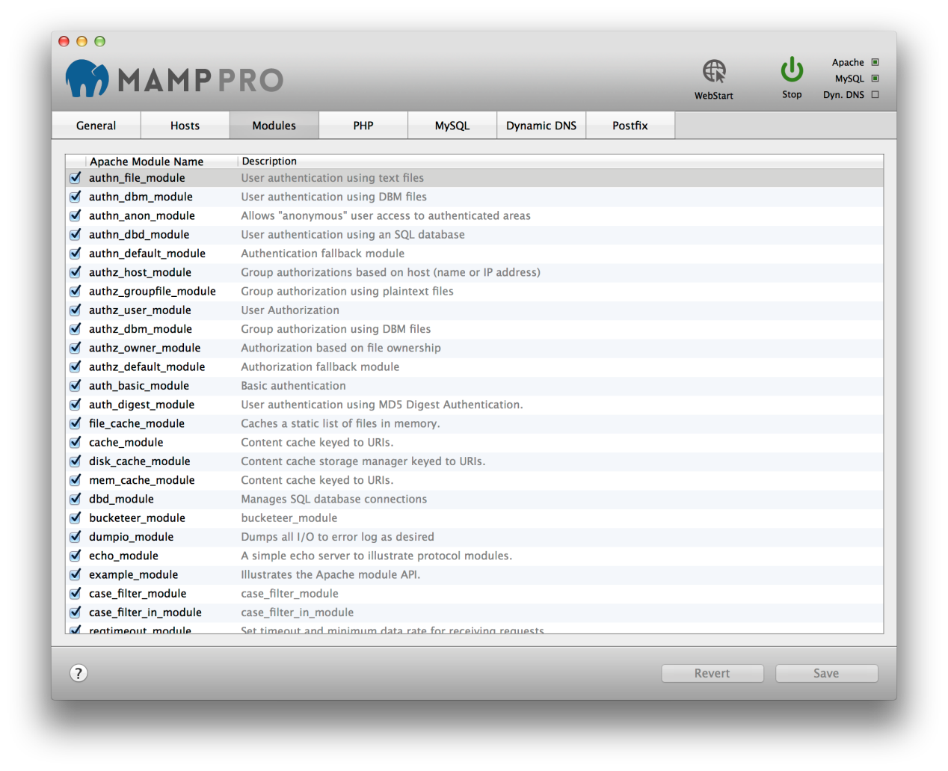

If you want to use the PHP scripting language you must activate the php_module, if you want to use Python you need mod_wsgi module, Perl needs perl_module.

If you want to be able to switch to CGI mode and use multiple PHP versions you must activate cgi_module.

### 4.4 PHP

PHP is a popular web scripting programming language. MAMP PRO installs several versions of the PHP script interpreter.

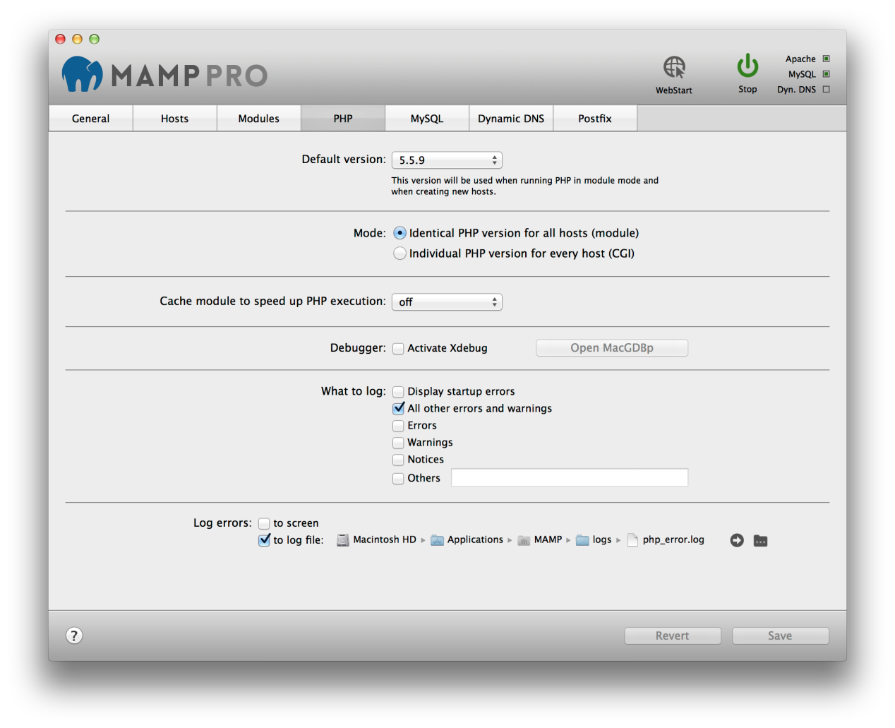

**Default version**

Choose which PHP version to use.

**Mode**

Choose whether to use identical PHP versions for all hosts [Module Mode] or on a host by host basis [CGI Mode]. In CGI Mode the PHP settings will be identical for all hosts – except for the PHP version. Navigate to the Hosts section to change the PHP version for each individual host. More information on how to change the PHP version for an individual host is covered in the ‘Hosts’ section.

**Cache Module to speed up PHP execution**

PHP has several cache extensions that can help speed up execution in certain circumstances. This is set to ‘off’ by default. Enabling a cache extension does not necessarily translate to greater execution speed.

**Debugger**

**Activate Xdebug**

Activate Xdebug to allow PHP to create debugging information during script execution. By default, Xdebug uses localhost and port 9000 in the PHP.ini file.

**Open MacGDBp**

With Xdebug activated you can open the MacGDBp debugger to enable PHP debugging. By default, MacGDBp expects debugging information on port 9000 of localhost. See <http://www.bluestatic.org/software/macgdbp/> for more information.

**What to log**

Determine which error types should be reported.

Display startup errors: Log PHP errors that occur when Apache loads the PHP module.

All errors and warnings: All errors will be reported.

Errors: Script errors that make the further execution of the current PHP script impossible.

Warnings: General errors in the PHP environment.

Notices: Possible problems, that do not concern PHP, but which could be a notice of an error in a script.

Other: Report further error types through constants. Please turn to the PHP documentation for further information.

**Log Errors**

Determine if these errors should be recorded in a log file and/or displayed in the web browser window.

### 4.5 MySQL

The MySQL database server is a popular database used on production servers. An installation of MySQL is installed on your computer by MAMP PRO.

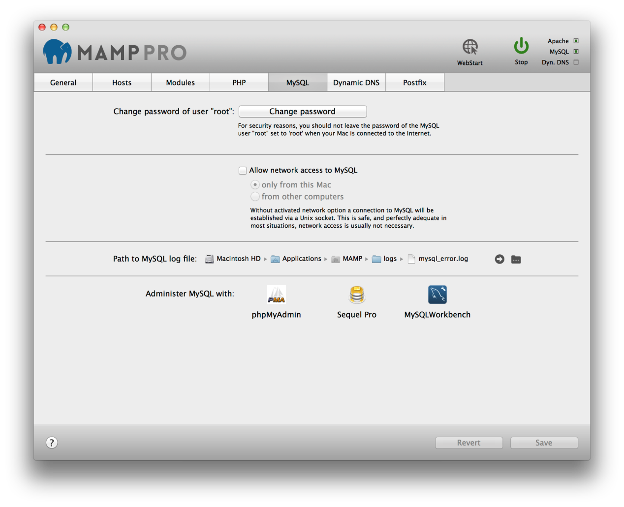

**Change password of user “root”**

The Head Database Administrator is called root. This user has unlimited access to all databases. Therefore you should set the password to one only you know.

**Note:** The default password of root is “root". To make things even more confusing there is also a user root inside Mac OS X. Don’t confuse them. You can also use one of the MySQL administration tools to create other MySQL users if you do not want to use almighty root.

**Allow network access to MySQL**

If the checkbox for Allow network access to MySQL is not checked, network access to the database is prohibited, even from programs installed locally.

**Note:** This is an advanced feature not need for local development.

**Only from this Mac**

Only programs installed on this Mac can access MySQL via network functions.

**From other computers**

MySQL will answer any network request, even from computers on the internet, depending on you network settings.

**Path to MySQL log file**

Errors occurring at startup or during execution of the MySQL server will be saved in this log file.

**Administer MySQL**

MAMP PRO comes pre-installed with several MySQL administration tools.

phpMyAdmin is a web-based administrational tool. It allows you to change data and perform administrative duties like creating new databases.

Sequel Pro is a native Mac application. It allows you to create and visualise database schemas in addition to administrative duties.

MySQL Workbench is also a native Mac application from the makers of MySQL. It allows you to visually create database schemas in addition to administrative duties.

### 4.6 Dynamic DNS

If you would like to make your hosts accessible from the internet (Don’t forget about security then!), but do not have a domain name that points to your Mac, you will need a Dynamic DNS Service.

If your network is connected to the internet via a router and it can handle Dynamic DNS Services, then you don’t need to configure it with MAMP PRO.

Otherwise you will need to register with a Dynamic DNS Service and enter the username and password into the appropriate fields. Then you will need to tell MAMP PRO when to inform the Dynamic DNS provider about a change in your Macs IP address. It may be necessary when you restart your computer or a DSL/Cable modem re/establishes a connection.

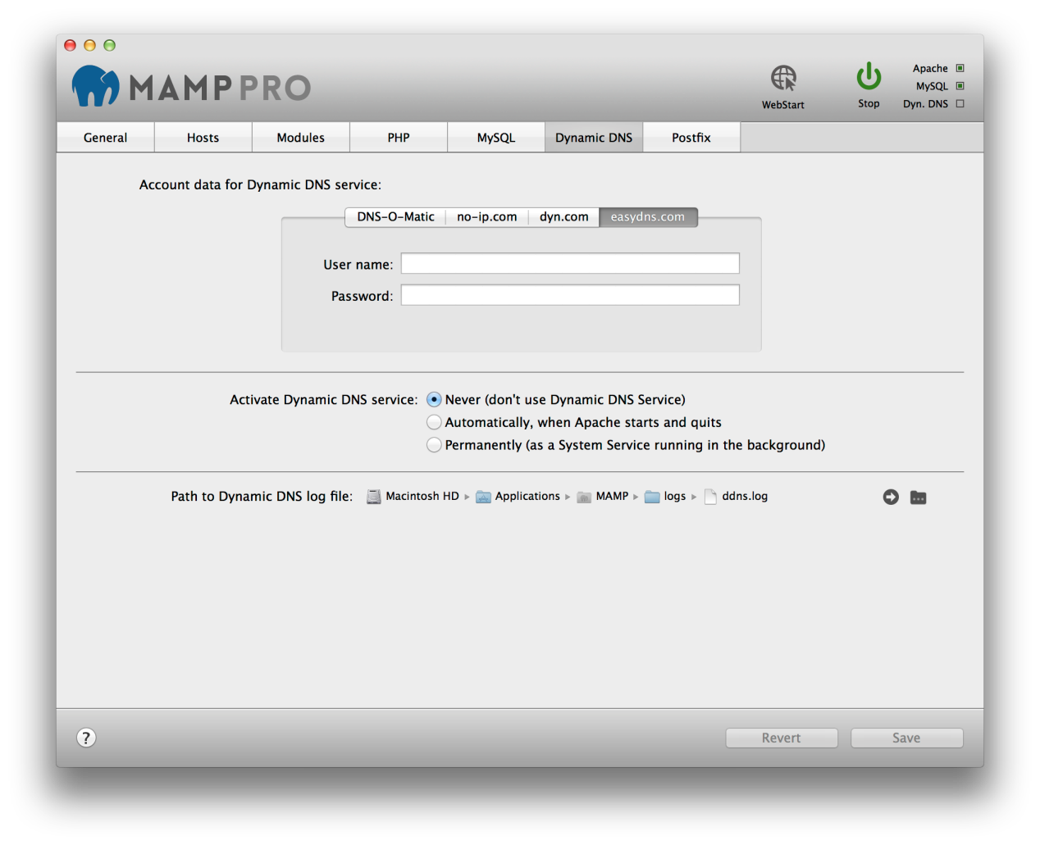

**Note:** To use the Dynamic DNS functions, you will need to register with one of the supported providers. This is independent of MAMP PRO and is not a service provided by appsolute GmbH.

**User name**

Enter the user name that was given to you by the provider of the Dynamic DNS Service.

**Password**

Enter the password that was given to you by the provider of the Dynamic DNS Service.

**Activate Dynamic DNS Service**

**Never (don’t use Dynamic DNS Service)**

Deactivate the "Dynamic DNS" service.

**Automatically, when Apache starts and quits**

Starts the "Dynamic DNS" service with the start of the Apache server.

**Permanently (as a System Service running in the background)**

Starts the "Dynamic DNS" service with the operating system. Only use this when your servers are running 24/7.

**Path to Dynamic DNS Log file**

All the events of the Dynamic DNS service will be recorded in a log file.

### 4.7 Postfix

Sometimes you may need to send an email with PHP. To do so you have to configure and start Postfix. An easy way getting Postfix to run is using the configuration tool built into MAMP PRO.

**Set domain of outgoing e-mails to**

If you want to use the PHP function mail() for sending emails to your own email address (like mail@johndoe.com) you just need to open MAMP PRO, go to Server -> Postfix and add the value "johndoe.com" (without quotes and the according domain name) into the field "Domain of outgoing mail”. Only if you want to send e-mail to others you will need to fill in the other fields. In this case make sure that your e-mail provider allows the use of a Smart host.

**Server name**Fill in your server name for outgoing emails. This could be for instance "smtp.johndoe.com" (without quotes). Ask your provider if you are unsure about the server name.

**User**

Add the user name of your mail account.

**Password**

Add the password for your email user account.

**Authentication**

Leave to “None"

**Note:** Some providers do not allow Smart-Hosts, like Google Mail.

Translate:

**4.主机和服务器设置**

**4.1一般**

|  |
| --- |
| **端口**  服务器程序，当经由网络寻址，需要被分配到一个特定的网络端口。通过这种方式，多个服务器程序可以在一个服务器计算机上运行。每个服务都有一个默认端口：Apache Web服务器通常使用80端口，MySQL数据库服务器使用的端口3306。  这些端口是可配置的。对于MAMP PRO的默认配置使用端口8888，8889和8890.这样，MAMP服务器可以一起安装在Mac上的其他服务器上运行。如果端口8888，8889和8890是由不同的应用程序使用，请相应地更改值。  该按钮将端口设置为80，443和3306将设置端口在互联网上常用的值。按钮设置默认甲基苯丙胺端口将用于Apache和MySQL的端口重置为8888，8889和8890。 |
| **启动Apache / MySQL作为用户**  生产服务器通常使用WWW / mSQL的运行Apache和MySQL。这些用户可能没有访问您的文件的权限，因此它通常是一个好主意，在你自己的用户名运行它们。  **注意：**您只需要使用自己的用户名启动服务器当机充分免受来自因特网的恶意攻击。您的服务器上的恶意脚本可以使无限制地访问您的个人资料。 |
| **在系统启动时启动Apache和MySQL**  Apache和MySQL OS的启动过程中开始，这意味着该服务可在用户登录到系统中之前。 |
| **在MAMP PRO启动启动Apache和MySQL**  该服务将在MAMP PRO的启动时自动启动。 |
| **停止Apache和MySQL在MAMP PRO停机**  当MAMP PRO关闭服务将自动停止。 |
| **删除日志文件在服务器启动**  日志文件将在服务启动前被清空。这样，目前唯一的作品将在日志文件中。 |
| **Apache的错误日志**  如果发生在启动或Apache服务器的执行过程中的任何错误，邮件将被保存在一个日志文件中 |

**4.2主机**

**4.2.1常规设置（主机）**

MAMP PRO使用虚拟主机，让Apache来提供不同的网站。虚拟主机[本地主机]默认情况下创建的，不能被删除。您可以添加主机的数量不受限制，允许您创建每个项目一个主机。每台主机可以有它自己的目录来存储HTML，PHP文件和图像。该目录被称为文档根。

主机[服务器名称]的名称必须是唯一的，往往是实际使用反向域名命名方案更容易识别它们（例如使用de.appsolute.mamp代替mamp.​​appsolute.de的）。该unreversed名称可能与外部域名冲突。

要创建一个新的主机按底部的“加号”按钮，屏幕左边。替换默认主机名。第二个必填字段，完成一个新的主机的设置是它的文件[文档根目录]的位置。

点击文件夹图标，选择文档根目录。使用右箭头键打开Finder中的文件夹。



文档根目录也被称为Web根文件夹。重新启动Apache的时候MAMP PRO会自动的index.php文件和MAMP图像添加到这个位置和文件夹为空。

**服务器名称**

服务器名称和端口号组合必须是MAMP PRO中是唯一的。主机名只能包含字母和/或数字，以及破折号（“ - ”）;但它可能不会开始或结束一个“ - ”字符。名称不区分大小写（大写和小写字母不区分。）



如果服务器正在运行，您可以使用右箭头按钮在Web浏览器中打开的主机。



**IP地址**

如果该字段为空或包含“*”Apache会使用计算机的IP的一个地址访问该主机。如果你想选择哪个IP地址应与主机相关联，然后从弹出菜单中选择。

**端口号**

确定与该虚拟主机进行访问的端口。有效值是1到65535在大多数情况下，预置值并不需要改变。

**PHP版本**

确定主机将使用的PHP版本。当个别PHP版本，每个主机（CGI）在MAMP PRO的PHP部分设置这只能进行设置。

如果你选择，如果你选择在PHP标签的新标准版的标准PHP版本MAMP Pro将自动适应此设置。使用固定设置告知MAMP PRO不改变PHP版本。

听起来很复杂？让我们看一个例子：默认版本设置为5.5.9。您已经oneHost设置为PHP版本“默认（5.5.9）”，anotherHost设置为“5.5.9”，并yetAnotherHost设置为“28年3月5日”。如果您在PHP部分的PHP版本设置为25年5月4日，MAMP Pro将oneHost的PHP版本适应这个版本（它被设置为始终使用标准版）。另2主机将不被改变。



该按钮将打开一个网页，提供有关使用的PHP版本，包括其所有扩展的信息。

**动态DNS**

确定，如果这个虚拟主机是从互联网动态DNS服务访问。

**名称解析**

这将决定你的系统将如何主机名映射到IP地址。

**通过/ etc主机文件（仅此Mac）**

它使用了文件/ etc/ hosts中的基本映射机制。

**通过Xip.io（仅LAN）**

让你的本地网络上的其他计算机来访问你的网站。使用共享按钮，你可以发送Xip.io地址给其他用户。

**注：**Xip.io地址只在本地网络中工作。他们是暂时的，如果你重新启动Mac可能会变得无效。另外，还要确保您的Internet路由器没有阻止Xip.io通过DNS重新绑定的保护要求。如果路由器做到这一点，你可以禁用这个功能，添加Xip.io作为例外或不使用路由器作为DNS服务器在你的Mac电脑的网络设置。

**文档根**

虚拟主机的文件（HTML/ PHP文件等）的位置称为文档根目录。

**别名**

别名是虚拟主机的其他名称。同样的限制适用于这些额外的名称作为主机本身。添加别名与加按钮。

**访问权限的文档根目录**

对于Apache要能够访问文档根目录文件夹中的文件，并将它们用于Web浏览器就需要足够的权限。如果您使用用户WWW启动Apache，那么该用户必须拥有访问文档根目录文件夹里面的文件的权利。通常不是这种情况。您可以调整访问权限，还是使用当前的Mac用户启动Apache。

在一个网站的发展阶段，它更容易使用的当前Mac用户启动Apache。用户WWW一般只用在生产服务器。



如果Apache是报告“拒绝访问”在错误日志或网页的某些部分缺失，这可能是由于访问权限的问题。

MAMP PRO的权利对话框如下一见钟情复杂，但实际上是非常强大的。它不仅表现出你和它里面的文档根目录文件夹的访问权限，而且所有子目录的所有权利的文件。 A“ - ”表示，并不是所有的对象都具有相同的权利。

**所有者**

谁拥有目录，其中的所有子目录和文件的用户。

**组**

谁有权访问该目录，其中的所有子目录和文件组。

**访问权限**

您可以单独更改目录和文件的访问权限

**4.2.2扩展（主机）**

扩展选项可以在表中所选择的虚拟主机进行设置。这些选项是有关安全的！



**为<目录>指令选项**

**索引**

开启或关闭“目录浏览”。如果没有的index.html，index.php文件等在文档根，启用该选项时，将显示该文件夹的内容。如果没有这个选项，不会显示任何内容或将出现一个错误信息。

**包括**

允许使用服务器端包含（SSI）。

**FollowSymLinks**

允许使用符号链接作为参考其他目录中的文件。这是一个优雅的功能，如果你想引用对象，是外目录树（Web服务器的例如协议文件），但知道你想要避免物体隐藏通过URL树。

**SymLinksIfOwnerMatch**

限制“的FollowSymLinks”的版本。允许通过符号链接引用对象只有在拥有者相匹配。

**EXEC-CGI**

允许CGI的执行。

**在Multiviews**

允许使用或依赖于语言的动态文档中禁用。

**目录索引**

确定是否没有文件名是在一个给定的地址的Apache应该成为其中的文件。默认情况下它可以是index.html或index.php文件。

**服务器管理**

电子邮件地址，Apache会发出错误消息。

**对于其他参数<目录>**

**对于其他参数的<VirtualHost>**

这些指令直接到httpd.conf文件。

**注意：**当心错别字，他们会以其他方式防止Apache启动。

**4.2.3 SSL（主机）**

从Apache的加密流量可以使用SSL的Web浏览器。

使用“创建自签署证书，”如果你想测试SSL功能。

如果要保护一个生产服务器，你应该得到的证书文件，并从认证机构（CA）证书密钥文件。



**4.2.4附加功能（主机）**

MAMP PRO让您轻松流行包添加到您的主机，我们称之为附加功能。演员将始终从appsolute服务器，如果您有互联网连接加载。随着时间的推移更多的附加功能将变得可用。

**注：**一个额外的供应将通过你的主机的PHP版本，互联网连接，缓存的附加功能和可用磁盘受到影响space.To添加一个额外的，按加号按钮，在'附加'面板的左下侧。加号按钮周围有一个红色的圆圈，如果你没有安装其他方案。

**4.2.4.1 WordPress**

**博客的名称：**命名您的博客。

**电子邮件地址：**您的电子邮件地址。

**注意：**您必须输入一个有效的电子邮件地址设置一个WordPress安装。

目录：

安装目录。如果是空白的WordPress的文件将被直接复制到文档根目录文件夹。

**注意：**不要安装在以前的安装的WordPress的！文件将没有警告被覆盖

**数据库名称：**

设置将被添加到本地数据库的数据库模式的名称。安装后，您可以查看该数据库使用phpMyAdmin的WordPress这种情况下，续集Pro或MySQLWorkbench。

**用户名：**

WordPress管理。

**注意：**您将需要此用户名登录到您的新WordPress的博客，请写下来。

**密码**：

WordPress的管理员默认密码。

注意：您将需要此密码登录到您的新WordPress的博客，请写下来。

**4.2.4.2 Joomla**

如果您在安装过程中提供了一个独特的表前缀的Joomla安装可以共享一个MySQL数据库。要使用现有的数据库输入数据库的名称和独特的表前缀。要创建一个新的数据库使用唯一的数据库名称，表的前缀不能为空。



**表前缀：**

设置你的数据库模式前缀的名字。的Joomla提供管理使用单一数据库模式多个网站的能力。

**数据库名称：**

设置将被添加到本地数据库的数据库模式的名称。安装后，您可以查看该数据库使用phpMyAdmin的Joomla这种情况下，续集Pro或MySQLWorkbench。

**4.2.4.3 webEdition**

webEdition将始终安装在文档根目录文件夹中的文件夹名为webedition。**表前缀：**

设置你的数据库模式前缀的名字。 webEdition提供管理使用单一数据库模式多个网站的能力。

**数据库名称：**

设置将被添加到本地数据库的数据库模式的名称。安装后，您可以查看该数据库使用phpMyAdmin webEdition的这种情况下，续集Pro或MySQLWorkbench。

**注意：**当一个内容管理系统设置的主机名和Apache端口号保存在数据库中。展望未来在MAMP PRO Apache的端口不能更改。在Apache的A口变化将导致破CMS，返回只有一个模糊的错误消息。内容管理系统通常用于改变主机和端口名提供的机制。如果更改了CMS做，那么他们也必须在MAMP PRO的。

**4.3模块（阿帕奇）**

通过MAMP PRO安装Apache Web服务器附带了许多模块预装。

**Apache模块**

Web服务器模块可以根据您的需要激活或停用。模块说明提供有关所选模块的特性和功能的信息。

如果你要使用的PHP脚本语言，你必须激活php_module，如果你想使用Python你需要的mod_wsgi模块，Perl的需要perl_module。

如果您希望能够切换到CGI模式，并使用多个PHP版本必须激活cgi_module。

**4.4 PHP**

PHP是一种流行的Web脚本编程语言。 MAMP PRO安装PHP脚本解释器的多个版本。

**默认版本**

选择要使用的PHP版本。

**模式**

选择是否使用相同的PHP版本的所有主机[模块模式]或主机的基础[CGI模式]的主机上。 CGI模式的PHP设置将是相同的所有主机 - 除了PHP版本。导航到主机部分更改PHP版本，每台主机。如何改变PHP版本，单个主机的更多信息覆盖在“主机”部分。

**高速缓存模块，以加快执行PHP**

PHP有几个缓存扩展，可以帮助加快在某些情况下执行。这被设置为默认“关闭”。启用缓存扩展并不一定转化为更高的执行速度。

**调试器**

**激活Xdebug**

激活Xdebug的允许PHP创建脚本执行期间的调试信息。默认情况下，Xdebug的使用本地主机和端口9000在php.ini文件。

**打开MacGDBp**

随着Xdebug的激活，您可以打开MacGDBp调试启用PHP调试。默认情况下，MacGDBp预计，调试本地主机上的端口9000的信息。见http://www.bluestatic.org/software/macgdbp/以获取更多信息。

**什么记录**

确定哪些错误类型应该报告。

显示启动错误：登录时阿帕奇加载PHP模块发生PHP错误。

所有的错误和警告：将报告的所有错误。

错误：脚本错误，使目前的PHP脚本是不可能的进一步执行。

警告：在PHP环境一般错误。

注意事项：可能出现的问题，不涉及PHP，但它可能是一个脚本错误的通知。

其他：通过常量报告进一步的错误类型。请打开进一步的信息，PHP文档。

**日志错误**

确定是否应该被记录在日志文件中，这些错误和/或在web浏览器窗口中显示。

**4.5 MySQL**

MySQL数据库服务器是在生产服务器上使用的流行的数据库。 MySQL的的安装您的计算机安装由MAMP PRO上。

**更改用户“根”密码**

该负责人数据库管理员被称为根。此用户不受限制地访问所有数据库。因此，你应该设置密码，一个只有自己知道。

**注：**根的默认密码为“根”为了让事情更混乱也有Mac OS X的内部用户root不要混淆他们还可以使用MySQL的管理工具来创建其他MySQL用户。如果你不希望使用全能根。

**允许MySQL的网络访问**

如果允许MySQL的网络访问复选框未选中，对数据库的网络访问被禁止，甚至从本地安装的程序。

**注：**这是一种先进的功能并不需要为当地的发展。

**仅从这台Mac**

只有安装在此Mac上的程序可以通过网络功能的访问MySQL。

**从其他计算机**

MySQL会回答任何网络请求，甚至从电脑在互联网上，这取决于你的网络设置。

**路径到MySQL日志文件**

在启动或MySQL服务器的执行过程中发生的错误将被保存在这个日志文件中。

**管理MySQL**

MAMP Pro预装预装有几个MySQL管理工具。

phpMyAdmin是一个基于Web的执政工具。它允许您更改数据，并执行像创建新数据库的管理职责。

Sequel Pro是一个原生Mac应用程序。它允许你创建和除行政职责可视化数据库模式。

MySQL的工作台也从MySQL的创造者一个原生Mac应用程序。它可以让你在视觉上除了行政职务创建数据库模式。

**4.6动态DNS**

如果你想使你的主机从Internet访问（不要忘了安全呢！），但没有指向您的Mac一个域名，您将需要一个动态DNS服务。

如果您的网络是通过路由器连接到互联网，它可以处理动态DNS服务，那么你就需要用MAMP PRO配置。

否则，你将需要使用动态DNS服务注册，输入用户名和密码到相应的字段。然后，你需要告诉MAMP PRO时通知动态DNS供应商了解您的Mac电脑的IP地址发生变化。当您重新启动计算机或DSL/ Cable调制解调器RE /建立连接，可能是必要的。



**用户名**

输入是由动态DNS服务的提供商提供给您的用户名。

**密码**

输入是由动态DNS服务的提供商提供给您的密码。

**激活动态DNS服务**

从不（不要使用动态DNS服务）:

禁用“动态DNS”服务。

自动，当阿帕奇启动和退出:

启动与Apache服务器启动的“动态DNS”服务。

永久（作为系统服务在后台运行）:

开始与操作系统的“动态DNS”的服务。只有当你的服务器运行全天候使用。

**路径动态DNS日志文件**

动态DNS服务中的所有事件将被记录在日志文件中。

**4.7后缀**

有时你可能需要使用PHP发送电子邮件。要做到这一点，你必须配置和启动后缀。一个简单的方法让Postfix的运行使用内建MAMP PRO配置工具。

**传出电子邮件以设置域**

如果你想使用PHP函数的mail（）发送电子邮件到您自己的电子邮件地址（如mail@johndoe.com），你只需要打开MAMP PRO，进入服务器 - > Postfix和增加值“johndoe.com” （不带引号和根据域名）进入该领域“外发邮件的域名。”只有当你想将电子邮件发送给其他人，您需要填写等领域。在这种情况下，请确保您的电子邮件供应商允许使用的智能主机的。

**服务器名称**

填写为外发邮件的服务器名称。这可能是例如“smtp.johndoe.com”（不含引号）。问问你的供应商，如果您不确定服务器名称。

**用户**

添加您的邮件帐户的用户名。

**密码**

您的电子邮件的用户帐户添加密码。

**认证**

离开“无”

**注意：**有些供应商不允许智能主机，像谷歌邮件。

## 5. Menu

### 5.1 MAMP PRO

**Check For Updates**

Check MAMP PRO updates checks for updates to the MAMP PRO application. It does not check for new versions of individual components.

**Preferences…**

Open WebStart when starting MAMP PRO

Your default browser will bring up the web start page when MAMP PRO is launched.

**Path To Webstart**

The default MAMP start page provides links to access utilities such as phpMyAdmin, phpInfo, SQLite Manager, phpLiteAdmin, FAQ, and the MAMP Website.

 When left using the default setting (/MAMP/), you will be directed to the MAMP PRO utilities start page using the Alias definition /MAMP/. If this field is left blank, you will be taken to your default document root ([http://localhost:8888](http://localhost:8888/) in the/Applications/MAMP/htdocs). If you enter /subDirectory in this field, you will be taken to the/Applications/MAMP/htdocs/subDirectory folder via your default web browser ([http://localhost:8888](http://localhost:8888/)/subDirectory).

**Allow Saving when Document Root is invalid**

MAMP PRO will ignore invalid paths to hosts and proceed with saving your settings.

**Allow Saving when IP Address is invalid**

MAMP PRO will ignore invalid IP addresses for hosts and proceed with saving your settings.

**Note:** Setting these options may prevent Apache from starting up.

**Automatically Restart Servers if necessary (don’t ask)**

MAMP PRO will automatically restart when changes are made that require a restart.

**Keyboard shortcut for MAMP**

Only M cannot be used as a shortcut key. The ^ key stands for the ctrl key.

**Show Status in Menu Bar**

The elephant icon will appear in the Menu Bar. When MAMP PRO has the servers running the elephant icon will be blue, when the servers are not running the elephant will be black.

**Hide Doc Icon (OS X 10.7 or later)**

The Doc Icon will be hidden. This option will only take affect after the restart of MAMP PRO.

**Note:** You will not be able to see the MAMP PRO Menu Bar.

**Use Message Center (OS X 10.9 or later)**

The Message Center will inform you of when Apache and MySQL have started. The Message Center can only be used when the doc icon is hidden.

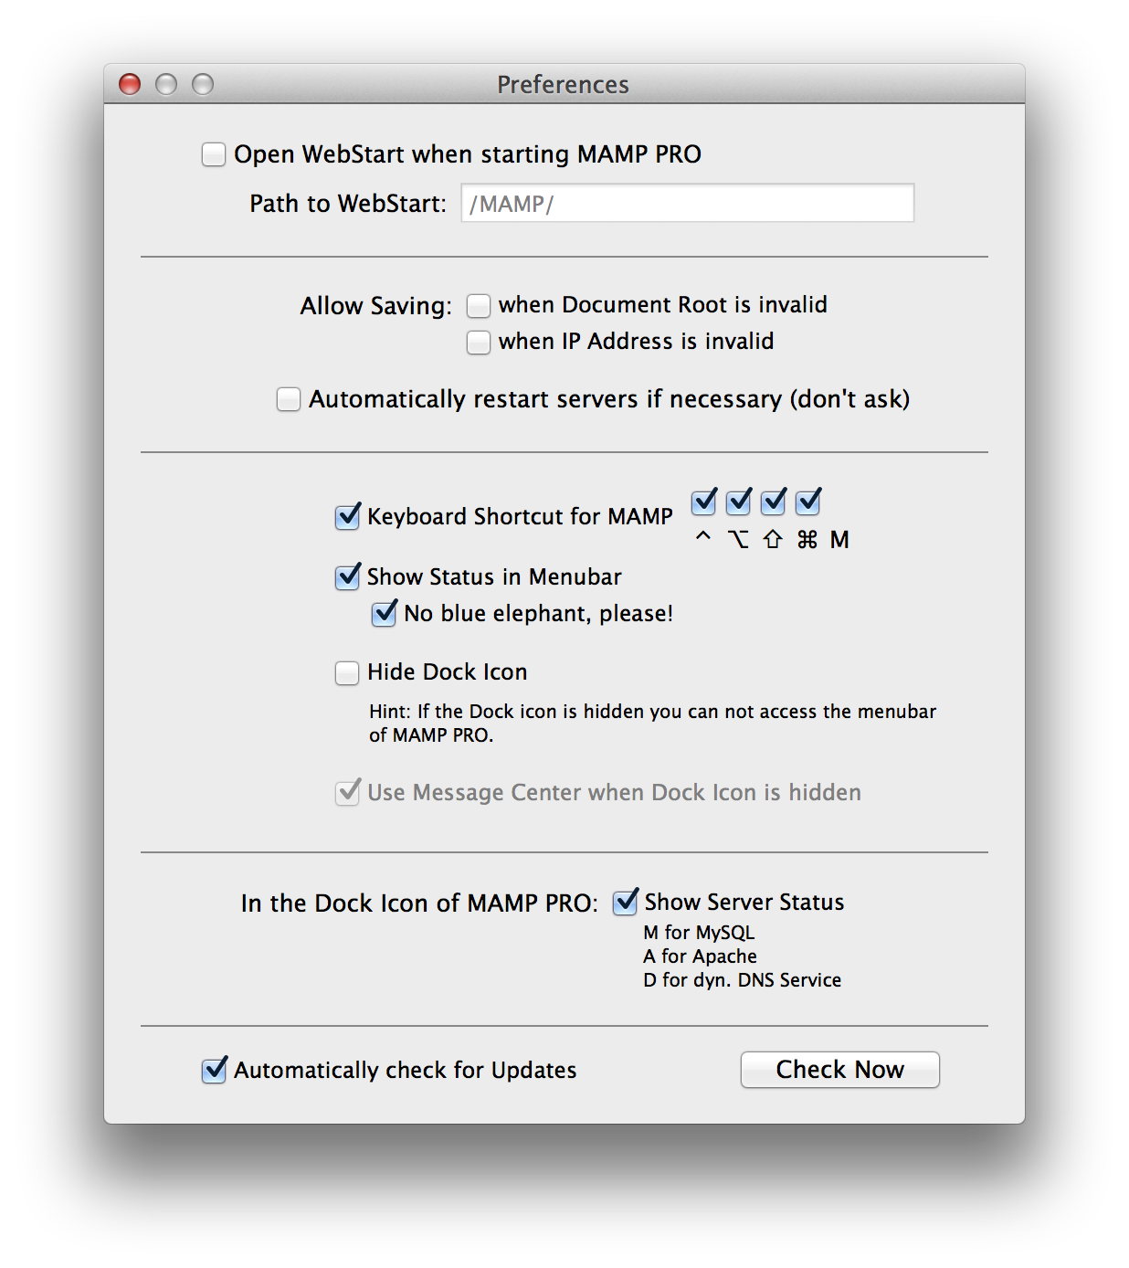

### 5.2 File

**Edit Template**MAMP PRO uses templates to create the necessary server config files. You can edit these templates from the menu item File > Edit template. Here, you have access to options which are not accessible from the MAMP PRO user interface.

**Note:**Edition errors in the templates of the configuration files can cause the servers not to start. This could mean that you will have to reset the settings for MAMP PRO, and you may lose all your other custom settings. You should edit these templates only if you are familiar with the exact syntax and meaning of the options.

**Factory Settings**

Development

Development will reset all your host and server settings back to default, including setting your Apache ports back to 8888, 8890, 8889, and your Apache User/MySQL User to username/username.

Live  
Live will reset all your host and server settings back to default, including setting your ports back to 80, 440, 3306, and your Apache User/MySQL User to www/mysql.

Backup…

Make a backup of all your host settings and database files.

**Note:** The backup feature makes a backup of your current host settings. It will **not**back up the files(.php, .html, .js etc…) in a hosts document root!

Restore From Backup

Restore your host settings and MySQL database files.

### 5.3 Log

The MAMP server record events like errors in so-called log files. Use the MAMP PRO menu to display the content of these files.

### 5.4 Tools

**Extras**

Go directly to the Extras pane of the last selected host.

**Verify MySQL Databases**

Get a complete list of schemas and tables inside of your MySQL Database. The database must be running in order for this function to work.

**Repair MySQL Databases**

Runs mysqlcheck which performs table maintenance.

**Update MySQL Databases**

Update your databases. The server must be shutdown to use this function.

**Save MySQL Databases**

Make a backup of your databases. The server must be shutdown to use this function.

**Show Hosts File**

The hosts file is located in the /etc directory, it maps host names to the IP address of your Mac. The host file contains the host names. Host entries created by MAMP PRO are marked by “# MAMP PRO - Do NOT remove this entry!”. These will disappear when Apache is shut down.

**Start System Apache / Web Sharing**

Enable the Apache server that is included with Mac OS X.

**5.菜单**

**5.1 MAMP PRO**

**检查更新**

检查MAMP PRO更新检查更新到MAMP Pro应用程序。它不检查单个组件的新版本。

**优先…**

开始MAMP PRO当打开在webstart

当MAMP PRO启动您的默认浏览器将弹出网页起始页。

***路径要Webstart***

默认的甲基苯丙胺开始页面提供的链接来访问工具如phpMyAdmin的，PHPINFO，SQLite的经理，phpLiteAdmin，FAQ，以及MAMP网站。

当使用默认设置（/ MAMP /）离开后，你将使用别名定义/ MAMP /被引导到MAMP PRO公用事业开始页面。如果该字段为空，你将被带到您的默认文档根目录（HTTP：//本地主机：8888在/应用程序/ MAMP / htdocs目录）。 （：//本地主机：8888 /子目录HTTP），如果在此字段中输入/子目录中，您将通过默认Web浏览器要采取的/应用程序/ MAMP / htdocs中/子目录中的文件夹。

***允许保存在文档根目录无效***

MAMP PRO会忽略到主机无效的道路，和保存设置进行。

***允许保存时的IP地址是无效的***

MAMP PRO将忽略无效的IP地址的主机，并保存设置进行。

**注意：**设置这些选项可以防止Apache启动。

***自动重新启动服务器（如有必要，不问）***

更改时需要重新启动MAMP PRO会自动重启。

***键盘快捷键为Mamp***

只含有M不能被用作一个快捷键。 ^键代表Ctrl键。

***在菜单栏中显示状态***

大象图标将出现在菜单栏中。当MAMP PRO具有运行大象图标将变成蓝色，服务器，当服务器运行的不是大象会变黑。

***隐藏文件图标（OS X 10.7或更高版本）***

该文件图标将被隐藏。此选项将只需要MAMP PRO的重启后的影响。

***注意：***您将无法看到MAMP PRO菜单栏。

***使用中的信息中心（OS X10.9或更高版本）***

信息中心将通知您何时Apache和MySQL已经开始的。当该文档图标被隐藏在消息中心只能用。



**5.2文件**

**编辑模板**

MAMP PRO使用模板来创建所需的服务器配置文件。您可以编辑从菜单项文件>编辑模板，这些模板。在这里，你可以访问哪些不能从MAMP PRO用户界面访问的选项。

**注意：**在配置文件中的模板版的错误可能导致服务器不启动。这可能意味着你将不得不重置MAMP PRO的设置，你可能会失去所有的其他的自定义设置。只有当你熟悉的选项的确切语法和含义，你应该修改这些模板。

**出厂设置**

发展

发展将重置回你的所有的主机和服务器设置为默认，包括设置你的Apache端口回到8888，8890，8889，和您的Apache用户/ MySQL的用户，以用户名/用户名。

生活

现场将重置所有的主机和服务器设置恢复到默认情况下，包括设置你的端口回80，440，3306，和您的Apache用户/ MySQL的用户到www / MySQL的。

备份...

让您的所有主机设置和数据库文件的备份。

注意：备份功能使得您当前的主机设置的备份。它不会在主机文档根目录备份的文件名（.php和.html，.js文件等）！

从备份中恢复

还原主机的设置和MySQL数据库文件。

**5.3登录**

该MAMP服务器记录的事件，如所谓的日志文件中的错误。使用MAMP PRO菜单显示这些文件的内容。

**5.4工具**

**附加功能**

直接进入最后选定主机的额外窗格。

**验证MySQL数据库**

让你的MySQL数据库里面的模式和表的完整列表。数据库必须为了使此功能工作运行。

**修复MySQL数据库**

运行mysqlcheck的其中执行表维护。

**更新MySQL数据库**

更新数据库。服务器必须关闭使用该功能。

**保存MySQL数据库**

让你的数据库的备份。服务器必须关闭使用该功能。

**显示Hosts文件**

hosts文件位于/ etc目录下，它的主机名映射到你的Mac的IP地址。主机文件包含的主机名。由MAMP PRO创建主机条目被标记为“＃MAMP PRO - 不删除该条目！”。 Apache的时候关闭这些都将消失。

**启动系统的Apache/网络共享**

启用附带的Mac OS X的Apache服务器

## 6. FAQ

### 6.1 What is MAMP PRO?

MAMP PRO is the commercial, professional grade version of the classic local server environment for Mac OS X: MAMP. Designed for professional web developers and programmers, MAMP PRO allows easy installation and administration of their development environment under Mac OS X.

### 6.2 Are updates free of charge?

Yes, all updates in the current major version (3.x) are free of charge. To update MAMP PRO from e.g. 3.1.2 to 3.9 just use the serial number you already have. Licenses are good forever, they are not on a subscription basis.

### 6.3 Is MAMP PRO compatible with Mac OS X 10.9 (Mavericks)?

Yes, MAMP PRO is indeed compatible with Mac OS X 10.9 (Mavericks).

### 6.4 Can I use MAMP at the same time as MAMP PRO?

Both applications, MAMP as well as MAMP PRO, are configuration tools for the tools inside the folder MAMP. Though you could run them simultaneously you should not do it. You would run into sporadic problems, even data loss may occur.

### 6.5 Which PHP modules are included?

To find out which PHP modules are included click on the (i) button in the host section when the servers are running. It will open a web page showing information about the selected PHP software.

### 6.6 Where do I find my registration number?

Open the dialog File/About MAMP PRO, it is shown there.

### 6.7 Is it possible to add an updated version of PHP?

Compiled binaries of the PHP interpreter can be found at <https://www.mamp.info/en/downloads/>. Drop this downloaded folder into your /Applications/MAMP/bin/php directory. Close and re-open your MAMP PRO application. Your new PHP version should now appear in the PHP drop down menu. MAMP PRO will only support PHP versions from the downloads page.

### 6.8 Can the port assignment be the same for MAMP and MAMP PRO?

You can set the same ports for MAMP and MAMP PRO but it is not recommended to run both applications at the same time.

### 6.9 Can I use MAMP at the same time as MAMP PRO?

Both applications, MAMP as well as MAMP PRO, are configuration tools for the tools inside the folder MAMP. Though you could run them simultaneously you should not do it. You would run into sporadic problems, even data loss may occur.

### 6.10 Where should I store my HTML and PHP pages?

By default, PHP and HTML Pages should be stored inside the MAMP /Applications/MAMP/htdocs folder. This folder is called "Document Root". The location of the document root folder can be changed in the host settings.

### 6.11 Is the ImageMagick PHP module included?

The ImageMagick PHP module is included by default, but you must enable it inside the php.ini template file. Remove the ‘;’ from the following line. You can reach your template file via File > Edit Template.

;extension=imagick.so

### 6.12 Which Apache modules are included?

Apache modules are located in the /Applications/MAMP/Library/modules folder.

### 6.13 Is it possible to install MAMP PRO on an external drive?

No, MAMP PRO (as well as MAMP) has to be installed on the system drive.

### 6.14 Will MAMP work if the MAMP folder is not located in the Applications directory?

No. In order to work properly the MAMP folder has to be located in the Applications folder.

### 6.15 Are the amount of virtual hosts aliases limited?

No, with MAMP PRO you can use as many hosts and aliases as you like.

### 6.16 Where can I find the log files?

Clicking the black right arrow will open the log file in the Console application.

### 6.17 Where exactly are the MAMP PRO files created or changed?

The following list contains all files which are created and changed by MAMP PRO and are not located within the MAMP PRO folder.

**MAMP PRO Settings and Files**

* /Library/Application Support/appsolute/MAMP PRO
* ~/Library/Application Support/appsolute/MAMP PRO
* ~/Library/Preferences/de.appsolute.mamppro.plist

**MySQL**

* /Library/Application Support/appsolute/MAMP PRO/db/mysql

**Dynamic DNS**

* /Library/LaunchDaemons/de.appsolute.mamp_dyndns.plist
* ~/Library/LaunchAgents/de.appsolute.mamp_dyndns.plist

**Autostart at system start**

* /Library/StartupItems/MAMP/MAMP
* /Library/StartupItems/MAMP/StartupParameters.plist

**Postfix**

* An existing postfix configuration will be backed up to /etc/postfix/MAMP_backup before writing a new config file.